**EXPERIMENT 5**

**AIM: Design a web page using Bootstrap’s Components - Grid system, Forms, Button, Navbar, Breadcrumb, Jumbotron**

**CODE:**

<!DOCTYPE html>

<html lang="en">

<head>

    <meta charset="UTF-8">

    <meta name="viewport" content="width=device-width, initial-scale=1.0">

    <title>Gamified</title>

    <link href="https://cdn.jsdelivr.net/npm/bootstrap@5.3.0/dist/css/bootstrap.min.css" rel="stylesheet">

    <style>

        .jumbotron {

            background-color: #f8f9fa;

            padding: 2rem;

            border-radius: 0.3rem;

        }

    </style>

</head>

<body>

    <!-- Navbar -->

    <nav class="navbar navbar-expand-lg navbar-light bg-light">

        <a class="navbar-brand" href="#">Gamified</a>

        <button class="navbar-toggler" type="button" data-bs-toggle="collapse" data-bs-target="#navbarNav" aria-controls="navbarNav" aria-expanded="false" aria-label="Toggle navigation">

            <span class="navbar-toggler-icon"></span>

        </button>

        <div class="collapse navbar-collapse" id="navbarNav">

            <ul class="navbar-nav">

                <li class="nav-item">

                    <a class="nav-link active" aria-current="page" href="#">Home</a>

                </li>

                <li class="nav-item">

                    <a class="nav-link" href="#">Features</a>

                </li>

                <li class="nav-item">

                    <a class="nav-link" href="#">Pricing</a>

                </li>

            </ul>

        </div>

    </nav>

    <!-- Breadcrumb -->

    <nav aria-label="breadcrumb">

        <ol class="breadcrumb">

            <li class="breadcrumb-item"><a href="#">Home</a></li>

            <li class="breadcrumb-item"><a href="#">Library</a></li>

            <li class="breadcrumb-item active" aria-current="page">Data</li>

        </ol>

    </nav>

    <!-- Jumbotron -->

    <div class="jumbotron text-center">

        <h1 class="display-4">Welcome to Gamified</h1>

        <p class="lead">This is a simple example of a Jumbotron component in Bootstrap.</p>

        <hr class="my-4">

        <p>It uses utility classes for typography and spacing to space content out within the larger container.</p>

    </div>

    <!-- Grid System -->

    <div class="container">

        <div class="row">

            <div class="col-md-6">

                <h2>Game Section 1</h2>

                <p>This is some content for the first column.</p>

            </div>

            <div class="col-md-6">

                <h2>Game Section 2</h2>

                <p>This is some content for the second column.</p>

            </div>

        </div>

    </div>

    <!-- Form -->

    <div class="container mt-4">

        <h2>Contact Form</h2>

        <form>

            <div class="mb-3">

                <label for="name" class="form-label">Name</label>

                <input type="text" class="form-control" id="name" required>

            </div>

            <div class="mb-3">

                <label for="email" class="form-label">Email address</label>

                <input type="email" class="form-control" id="email" required>

            </div>

            <div class="mb-3">

                <label for="message" class="form-label">Message</label>

                <textarea class="form-control" id="message" rows="3" required></textarea>

            </div>

            <button type="submit" class="btn btn-primary">Submit</button>

        </form>

    </div>

    <!-- Footer -->

    <footer class="bg-light text-center py-3 mt-4">

        <p>&copy; 2024 Gamified. All rights reserved.</p>

    </footer>

    <script src="https://cdn.jsdelivr.net/npm/@popperjs/core@2.11.8/dist/umd/popper.min.js"></script>

    <script src="https://maxcdn.bootstrapcdn.com/bootstrap/5.3.0/js/bootstrap.min.js"></script>

</body></html>

**OUTPUT:**

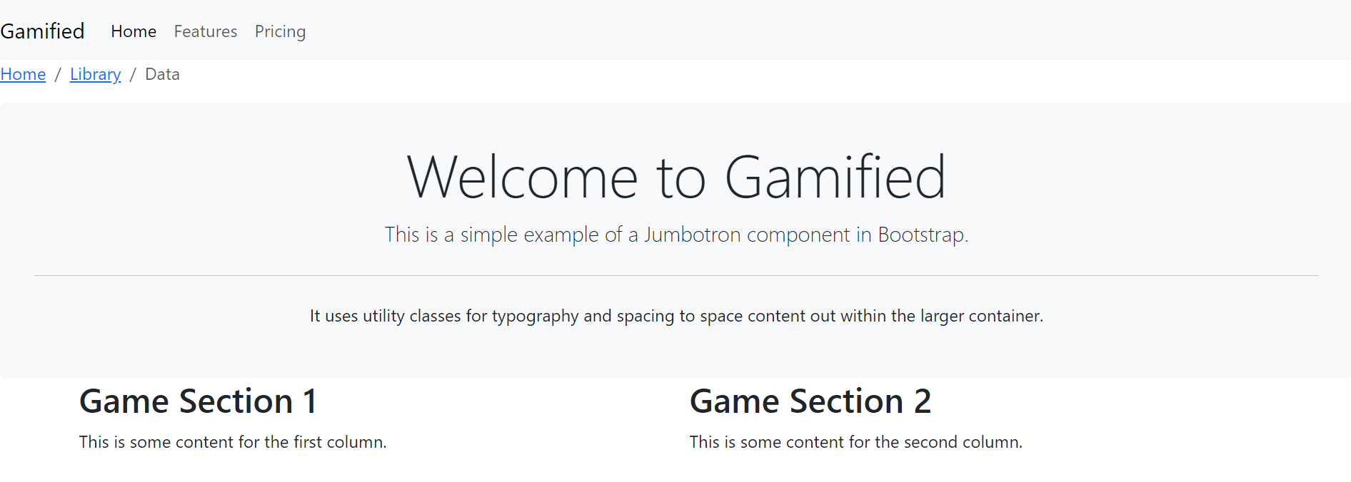

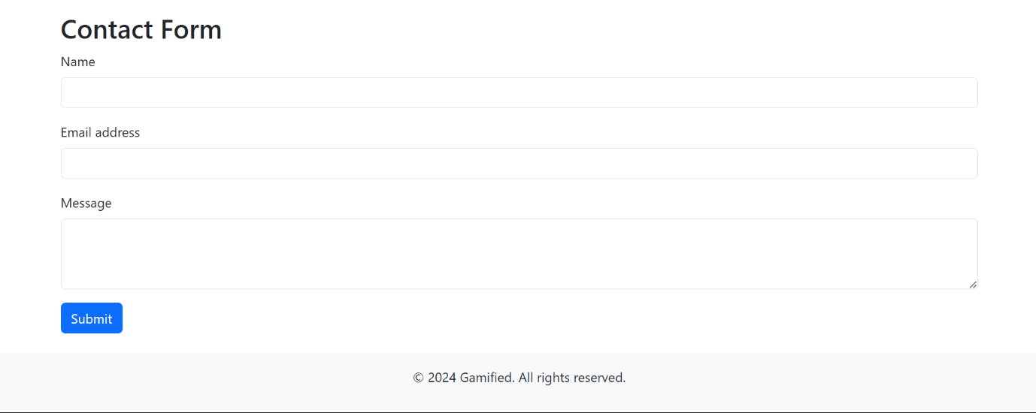

**CONCLUSION: Hence, we have successfully implemented a web page using Bootstrap’s Components - Grid system, Forms, Button, Navbar, Breadcrumb, Jumbotron**